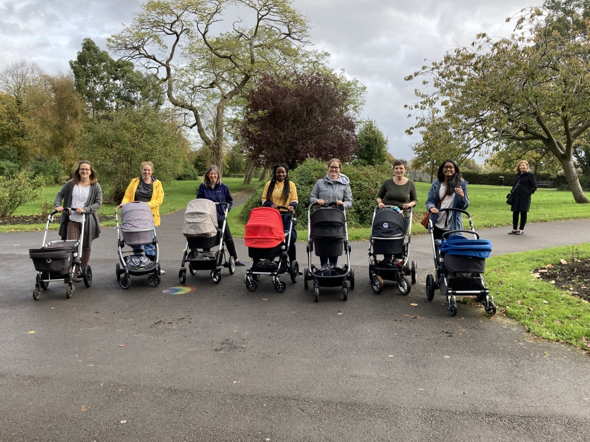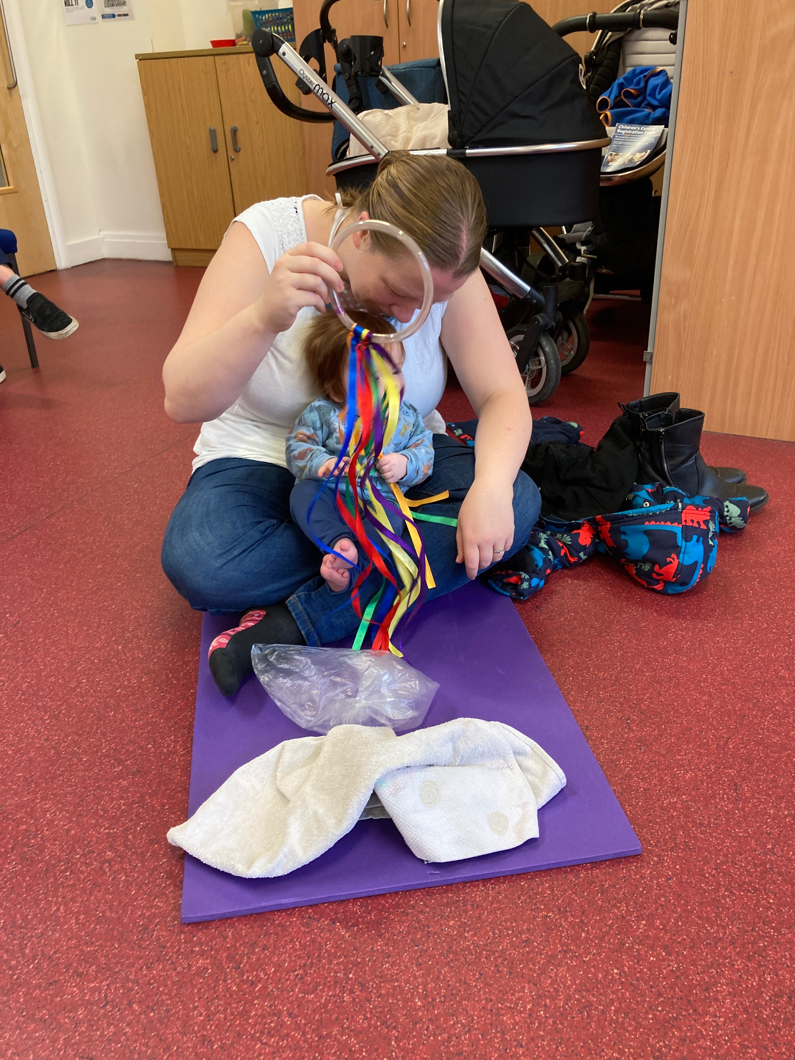

#### Face to Face groups

Wild Tots and Buggy Walks will both be postponed until further notice due to Government Guidelines.

Babes and Mums playing is moving to Zoom temporarily.

Firstly, we hope you are all well and had a fab Christmas and New Year safely with your families and little ones. As you are all aware we are still living in strange times and since the Prime Minister’s announcement on January 4th, we are back in lockdown.

Staff came back to work full of ideas to get groups up and running again, only for all plans to be put on hold. Please know we are always here to support you in any way we can. Please ring or email if you need any help. There are lots of Zoom groups now running instead until we can meet again face to face. Please see the attached timetable for all our different groups being held virtually.

Best Wishes from all the staff at Bedminster Children’s Centre.

**Bedminster Children’s Centre.**

Telephone Number:

0117 3746362

Anna works

Tues to Fri 8-4.

Email address:

[Anna.mcvey@bristol-schools.uk](mailto:Anna.mcvey@bristol-schools.uk)

Website:

<https://www.southbristolcc.org.uk/>

Facebook:

<https://bit.ly/2BPwBWi>

# HAPPY NEW YEAR

NEWSLETTER THREE: BEMMIE MUMS AND DADS

**JANUARY 2021**

# **Contact details**

To be able to attend this course you will need to register with our Children’s Centre and become a member.

You can register on our Website by going to the site clicking into the red box at the top of our page. It will take you to the Bristol City Council website where you can complete the on-line registration form.

To book a place please contact Anna at our Bedminster Children's Centre either by phone or email, contact details are located on the previous page.

**Blocks of Five to Thrive**

###### This group is ideal for Mums with new babies up to four months old. If your baby is older you may prefer the Mums and Babes playing group. Please see attachment.

## Newbie Parent Talk Group Three

# **FEATURED COURSE**

The group will meet on Wednesday’s

1.30-2.30pm from January 20th 2021 to

February 24th for seven weeks via Zoom.

This group will help you to socialise and develop an understanding of:

FIVE TO THRIVE

Session 1: January 20th Introduction. Early brain development and feeding.

Guest Speaker: Sandra Tanner from Bristol Breastfeeding support.

Session 2: January 27th RESPOND: Sleep patterns

Session 3: February 3rd CUDDLE: Baby massage

Guest Speaker: Leanne Evans Baby Massage Practitioner

Session 4: February 10th RELAX: Creating a wellbeing plan for you.

Guest Speaker: Nina Hollingsworth Chiropractor.

Session 5: February 17th PLAY: Creating play resources for your baby and tummy time.

Guest Speaker: Miriam Cain Allen.

Session 6: February 24th TALK: Speech and language session

Guest Speaker: Lucienne Green from Speech and Language

Final session: March 3rd Baby wellbeing and Weaning.

Guest Speaker: Team member from Bristol Breastfeeding support.

Each session will be led by Carole Theyer, an experienced Early Years practitioner with 40 years experience.

Each week there will be opportunities to go into break out rooms and discuss various issues and get to know each other.

There will be a chance to join a What’s App group and one or two buggy walks when Covid restrictions allow us to do so.

**Update from Bristol Breastfeeding Service**

**January 2021**

**Virtual group timetable**

|  |  |  |
| --- | --- | --- |
| Day | Time | Group |
| Monday | 10.30am – 12.00pm | Bristol Breastfeeding Support Service Monday group |
| Tuesday | 1.30-3.00pm | Bristol Breastfeeding Support Tuesday & Wednesday groups |
| Wednesday | 11.30am – 1.00pm | Bristol Breastfeeding Support Tuesday & Wednesday groups |
| Thursday | 10am | Honeysuckle Cafe |
| Thursday | 1-2.30pm | Lawrence Weston breastfeeding cafe |
| Friday | 10-11.30am | Bristol Breastfeeding Support Friday group |

We welcome expectant and breast feeding families in our groups where we can offer information and support on topics including, starting breastfeeding, expressing, overcoming challenges, introducing solids, returning to work and breastfeeding, mixed feeding, and stopping breastfeeding.

**Monday, Tuesday, Wednesday and Friday group support will be offered via Facebook**. **The two groups offering support on Thursday, will do so via zoom**. Please join their Facebook groups for details, or contact: [BristolBreastfeeding@bristol.gov.uk](mailto:BristolBreastfeeding@bristol.gov.uk)

Further details can be found on the ‘Bristol Breastfeeding Mummies’ Facebook group, as well as the ‘Bristol Breastfeeding Support Service’ and ‘Bristol Breastfeeding’ pages.

Important update from Sandra Tanner the breastfeeding lead about the Covid vaccine and breastfeeding women, please follow this link:

<https://www.rcog.org.uk/en/news/updated-advice-on-covid-19-vaccination-in-pregnancy-and-women-who-are-breastfeeding/?fbclid=IwAR3fDfTFzV6Lfj_ybmxRAwF_AQbPaFCnAJplZbUEga745d76PKasq0Nbbzk>

“The JCVI also now advises that there is no known risk in giving these vaccines to breastfeeding women. Breastfeeding women should therefore be offered vaccination if they are otherwise eligible, for example if they are a frontline health or social care worker, including a carer in a residential home. Women should be advised that there is lack of safety data for these specific vaccinations in breastfeeding.”

WILD TOTS

As we all know it is very important to get children outdoors and playing. As we can’t be with you face to face, we are planning to put together some outdoor ideas that you can do at home or locally outdoors.

We could set up a zoom group to meet weekly.

Firstly, we can email the ideas before each zoom group so that you can be ready.

Secondly join the group and share ideas between you.

Thirdly, when the weather is OK, but the Swedes do say,” there is no such thing as bad weather, only poor clothing” Get outside and have a great time playing. We will only go ahead if there is enough demand for the online group.

Could you let us know by Wednesday 20th January if you are interested, either emailing or phoning Anna at our Bedminster Centre. Contact details on page 1

Thanks

Carole

Further Information.