Bristol Breastfeeding Support Service
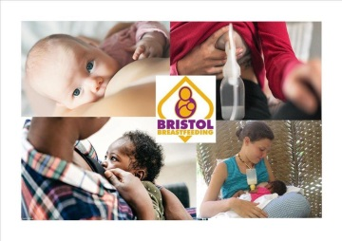
Virtual group timetable

Day | Time | Group
Monday | 10.30am – 12.00pm | Bristol Breastfeeding Support Service Monday group
Tuesday | 1.30-3.00pm | Bristol Breastfeeding Support Tuesday & Wednesday groups
Wednesday | 11.30am – 1.00pm | Bristol Breastfeeding Support Tuesday & Wednesday groups
Thursday | 10am | Honeysuckle Cafe
Thursday | 1-2.30pm | Lawrence Weston breastfeeding cafe
Friday | 10-11.30am | Bristol Breastfeeding Support Friday group

We welcome expectant and breastmilk feeding families in our groups where we can offer information and support on topics including, starting breastfeeding, expressing, overcoming challenges, introducing solids, returning to work and breastfeeding, mixed feeding, and stopping breastfeeding.
Monday, Tuesday, Wednesday and Friday group support is offered via facebook. The two groups offering support on Thursday, will do so via zoom. Please join their facebook groups for details, or contact: BristolBreastfeeding@bristol.gov.uk
Further details can be found on the ‘Bristol Breastfeeding Mummies’ facebook group, as well as the ‘Bristol Breastfeeding Support Service’ and ‘Bristol Breastfeeding’ pages.

