Social Media Messaging
Case numbers are high
The number of COVID-19 cases in your area is high.
We must all act now to bring the rate of infection down. Remember, whilst in lockdown:
· Stay at home where possible
· Wash your hands regularly
· Cover your face when heading to the supermarket or pharmacy
· Stay 2 metres apart from people you do not live with
· Only mix with your household or support bubble indoors
· For outdoor exercise, you can meet one person from another household
· If you have symptoms of COVID-19, please get a test and self-isolate
If you need support because you are self-isolating please phone the We Are Bristol Support Line 0800 694 0184
Please visit the government website for the latest guidance: https://www.gov.uk/guidance/new-national-restrictions-from-5-november
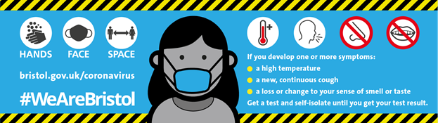
We Are Bristol Support hotline
If you or your family have to self-isolate the We Are Bristol Support hotline is here to help. We have a team volunteers in your area that can do your shopping, collect prescriptions, chat to you over the phone or walk your dog. Call now if you need support 0800 694 0184 (freephone, 8.30am to 5pm Monday to Friday, 10am to 2pm Saturday and, Sunday). If you are self-isolating please stay at home.
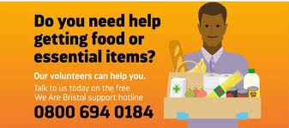

Support for people on low incomes
If you are on a low income and you have tested positive for Coronavirus so you have to self-isolate for 14 days you could be eligible for a grant of up to £500.
To be eligible you must:
- have been asked to self-isolate by NHS Test and Trace because you have tested positive for coronavirus or have recently been in close contact with someone who has tested positive
- be in low paid employment or self-employment
- be unable to work from home and will lose income as a result
You must make a claim within 14 days of ending your self-isolation. For more information on how to apply please visit
https://www.bristol.gov.uk/benefits-financial-help/covid-19-financial-help/test-and-trace-payment-support
